Dec 29 - Jan 5 – Task Sheet
GOOGLE CLASSROOM

Topics: Logistic Regression , KNN , SVM
Tasks:
1. Implement 5 different models to perform Decision Trees for 5 different dataset that prevails in csv format
2. Model Evaluation and Performance Metrics used in Machine Learning.
Topics: LeetCode
1.Solve 5 LeetCode Problems
Topics: GitHub
1.Submit this week complete work to your GitHub repo.
Topics: LinkedIn
1.Share your weekly task overview in your LinkedIn page with proper messages and images. Showcase Your work to public.
Topics: Video Recording in English Language
1.Record a self-video explaining your weekly task, what all challenges you faced and what output you got from this week.
2.Record a self-video explaining any one of the latest technologies in your interested area.
Extra Works
1.Build at least 30 connections in LinkedIn with HR, CEO’s and People from your Domain (Don’t send 30 requests in single day. Try to send 3 or 4 requests daily. Sending bulk connection requests in single day may spam your profile. Build your LinkedIn page as your Brand).

NB: Students, please fill the below details in proper way and upload this word file in to your google drive and share the link in google sheet.
Student Name: | ANUPAMA P T
Semester and Branch: | S4 CS(AI & DS)
Email id: | anupamaasrinivasan@gmail.com
Whether you completed all the assigned task in this week (Yes/No):

1. Implement 5 different models to perform Decision Trees for 5 different dataset that prevails in csv format

1. Titanic Survival Dataset 🚢 (Binary Classification)
- Goal: Predict if a passenger survived or not.
- Why it's good: This is the most popular dataset for Decision Trees. It helps you see how the tree "splits" the data—for example, the first split is often on "Sex," then "Age" or "Class."
- Direct Link: Kaggle - Titanic Dataset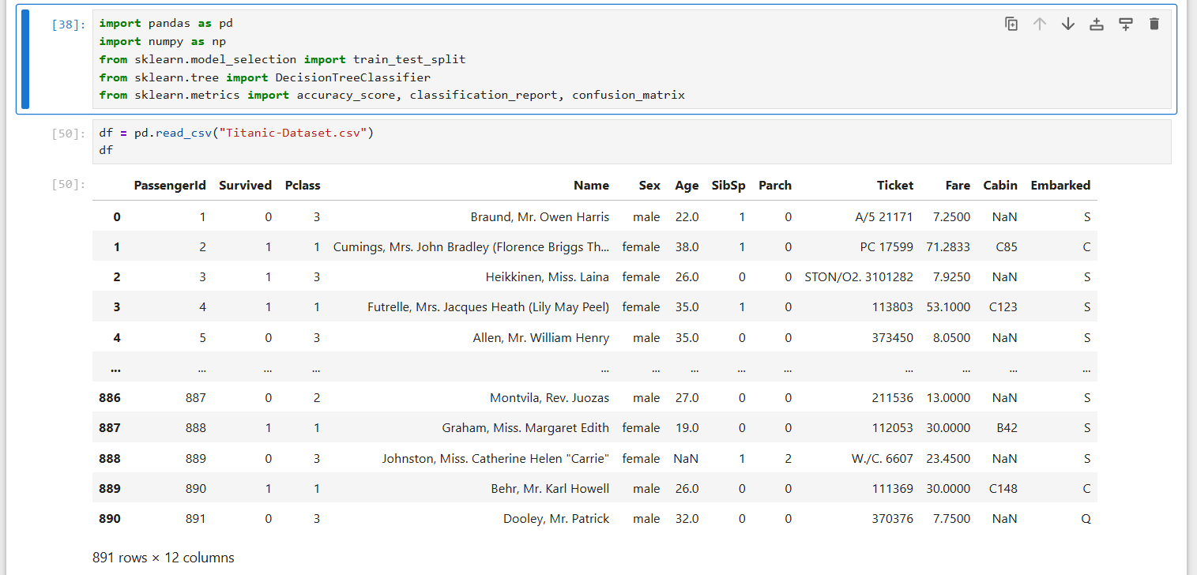
- 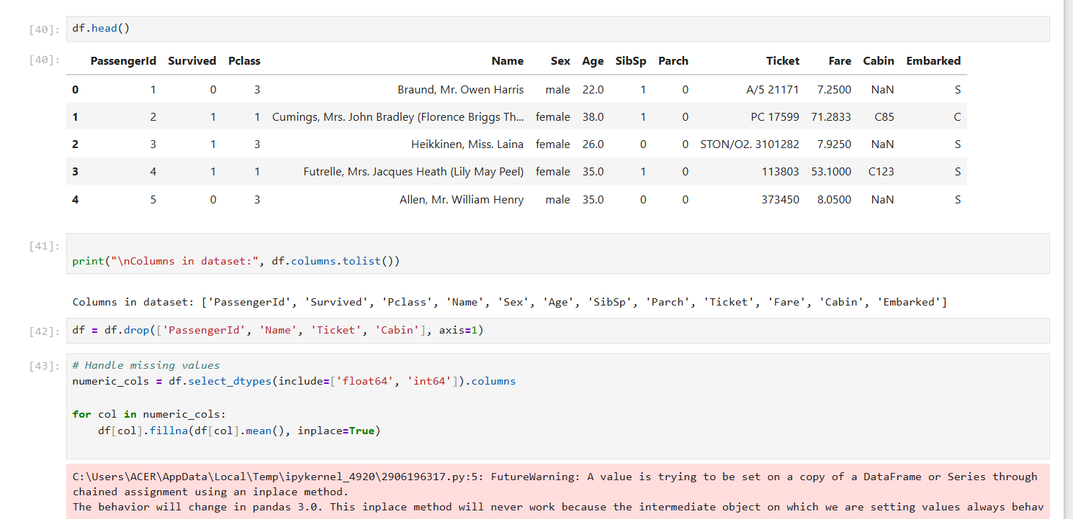
- 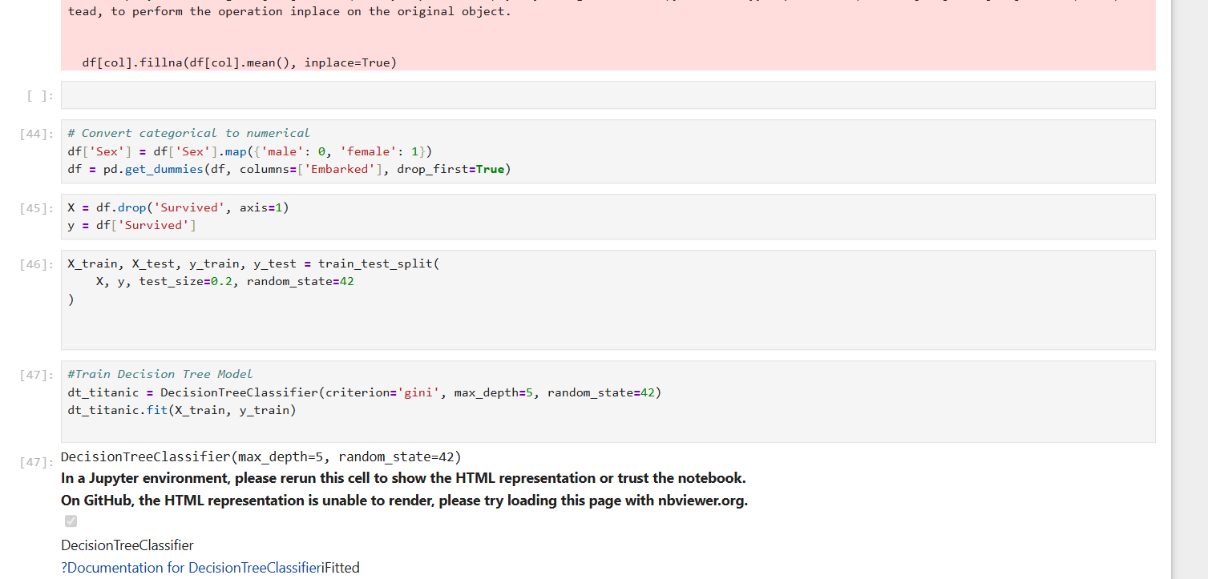
- 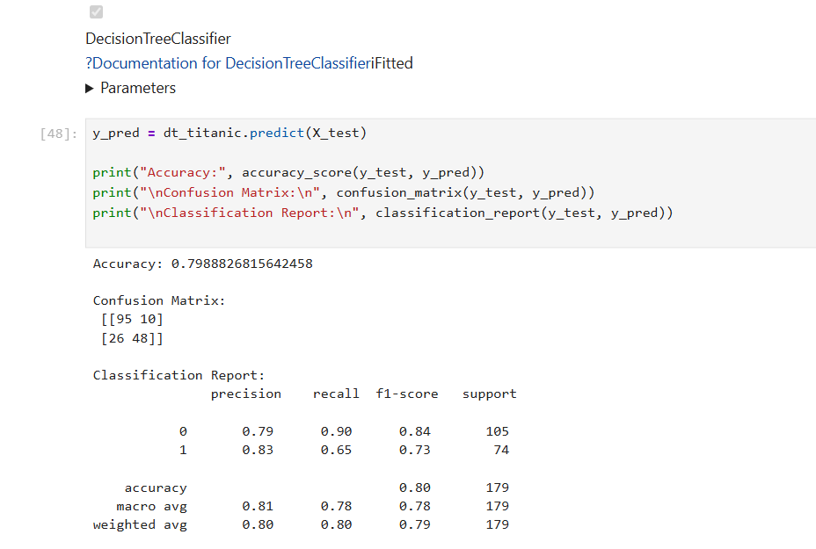
2. Iris Flower Dataset 🌸 (Multiclass Classification)
- Goal: Classify the species of an Iris flower.
- Why it's good: Decision Trees are great at finding clear "thresholds" for numerical data (e.g., if Petal Length > 2.45 cm, then class = Versicolor). You can easily visualize the entire tree because it stays small.
- Direct Link: Kaggle - Iris Dataset
- Note: Also available in sklearn.datasets.load_iris().
- 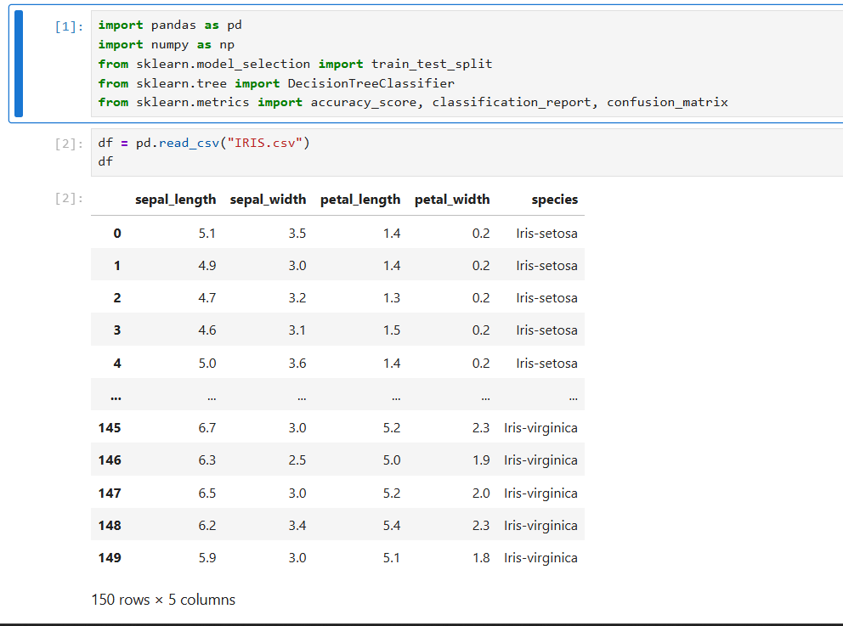
- 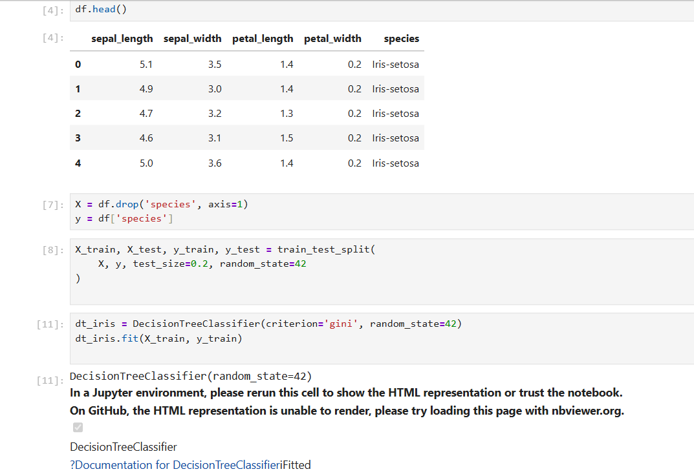
- 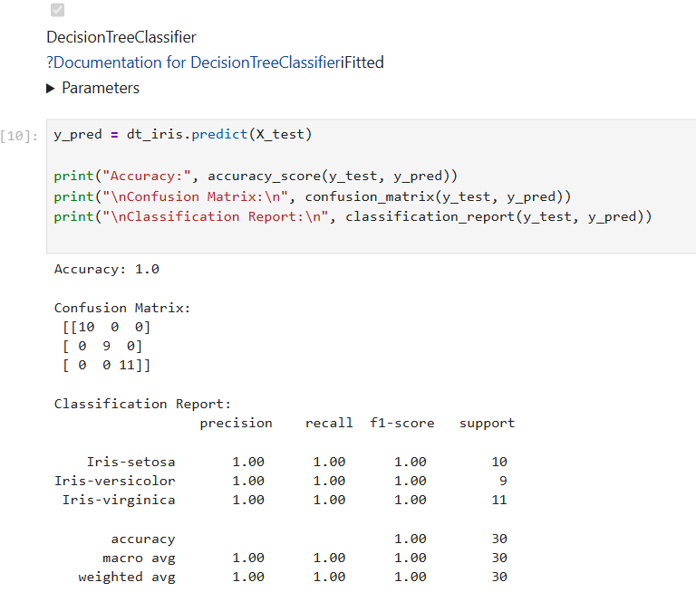
3. Adult Census Income Dataset 💰 (Binary Classification)
- Goal: Predict whether an individual's income exceeds $\$50\text{K}/year$ based on census data (age, education, occupation, etc.).
- Why it's good: This dataset has a mix of categorical (workclass, education) and numerical (age) data. Decision Trees handle this mixture naturally without requiring much pre-processing compared to algorithms like SVM.
- Direct Link: Kaggle - Adult Income Dataset
- 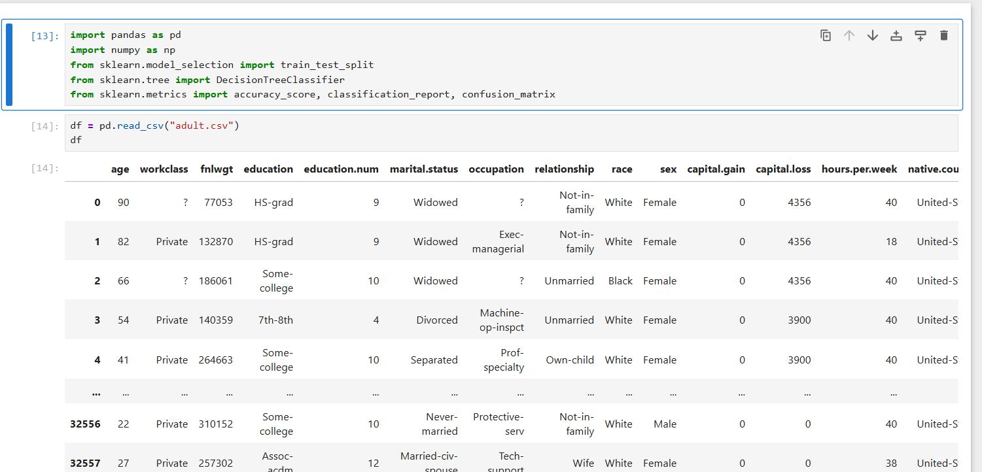
- 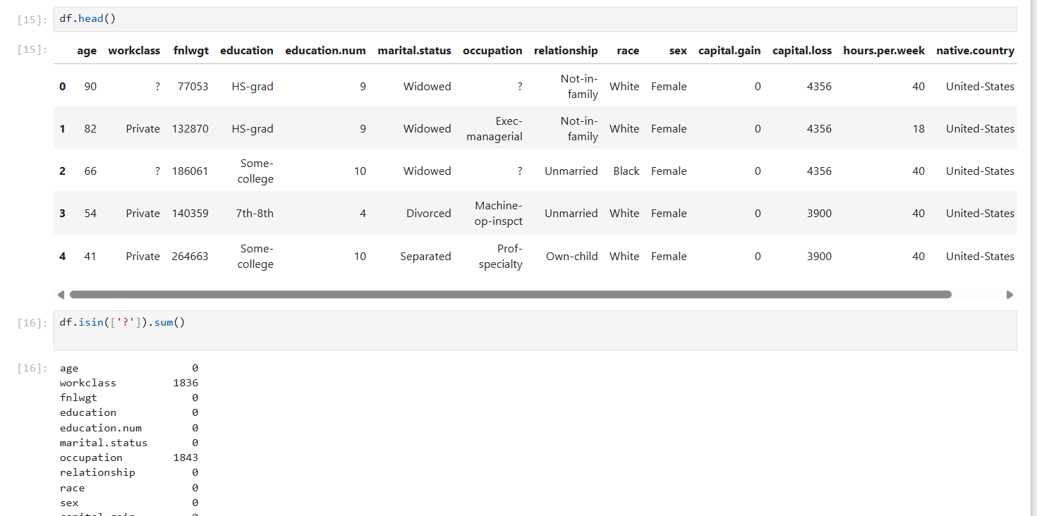
- 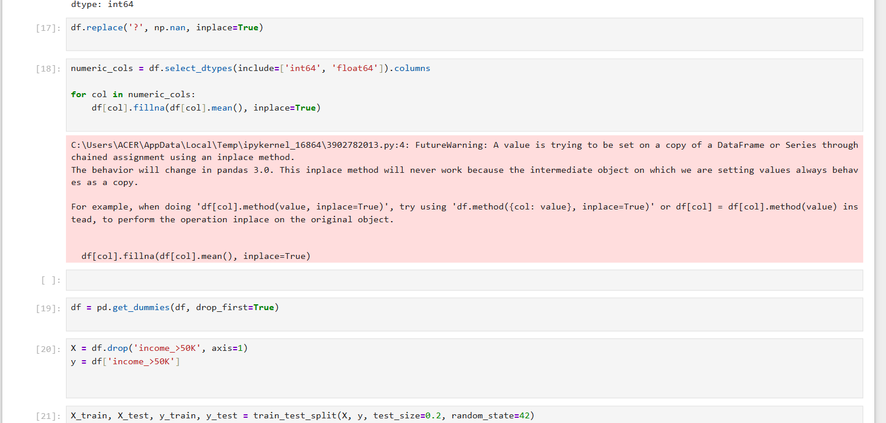
- 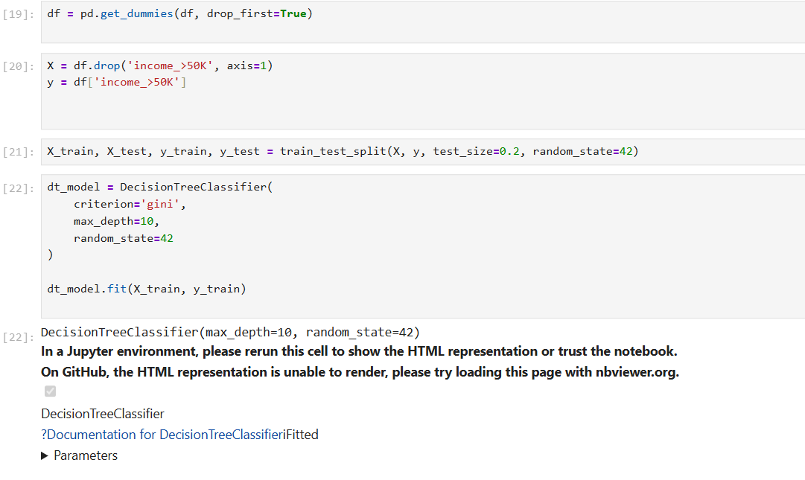
- 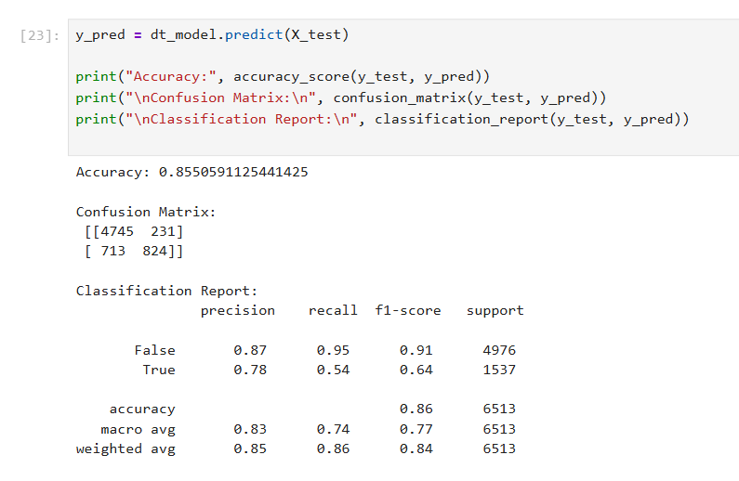
4. Breast Cancer Wisconsin 🎗️ (Binary Classification)
- Goal: Classify tumors as Malignant or Benign.
- Why it's good: Decision Trees are "interpretable." In a medical context, you can explain exactly why the model made a prediction by following the tree's branches, which is critical for doctors.
- Direct Link: Kaggle - Breast Cancer Dataset
- 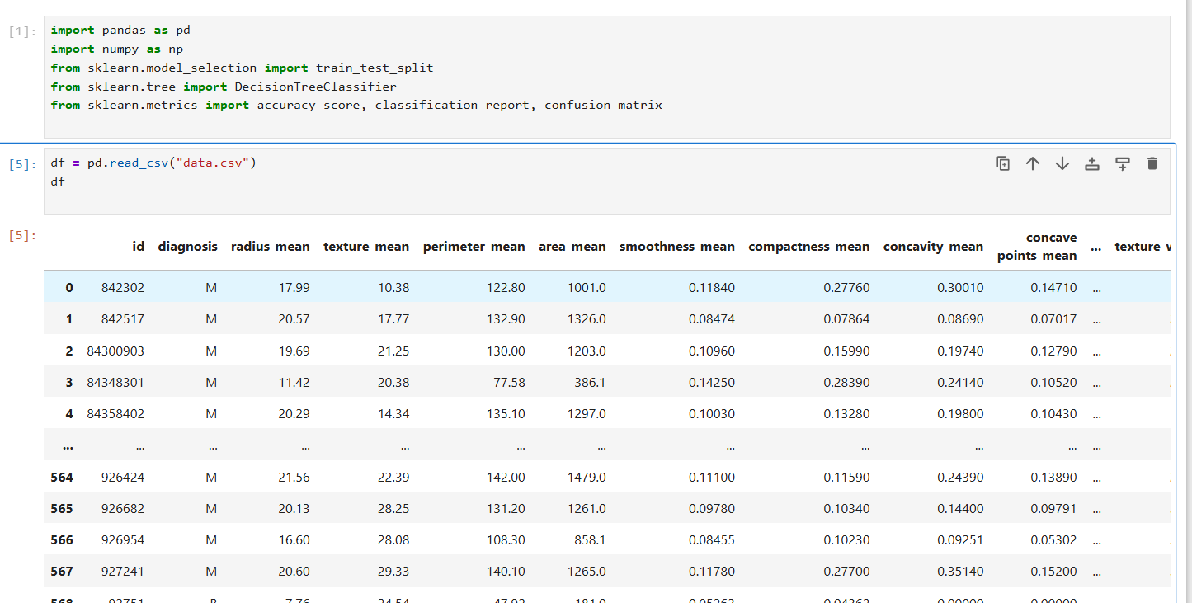
- 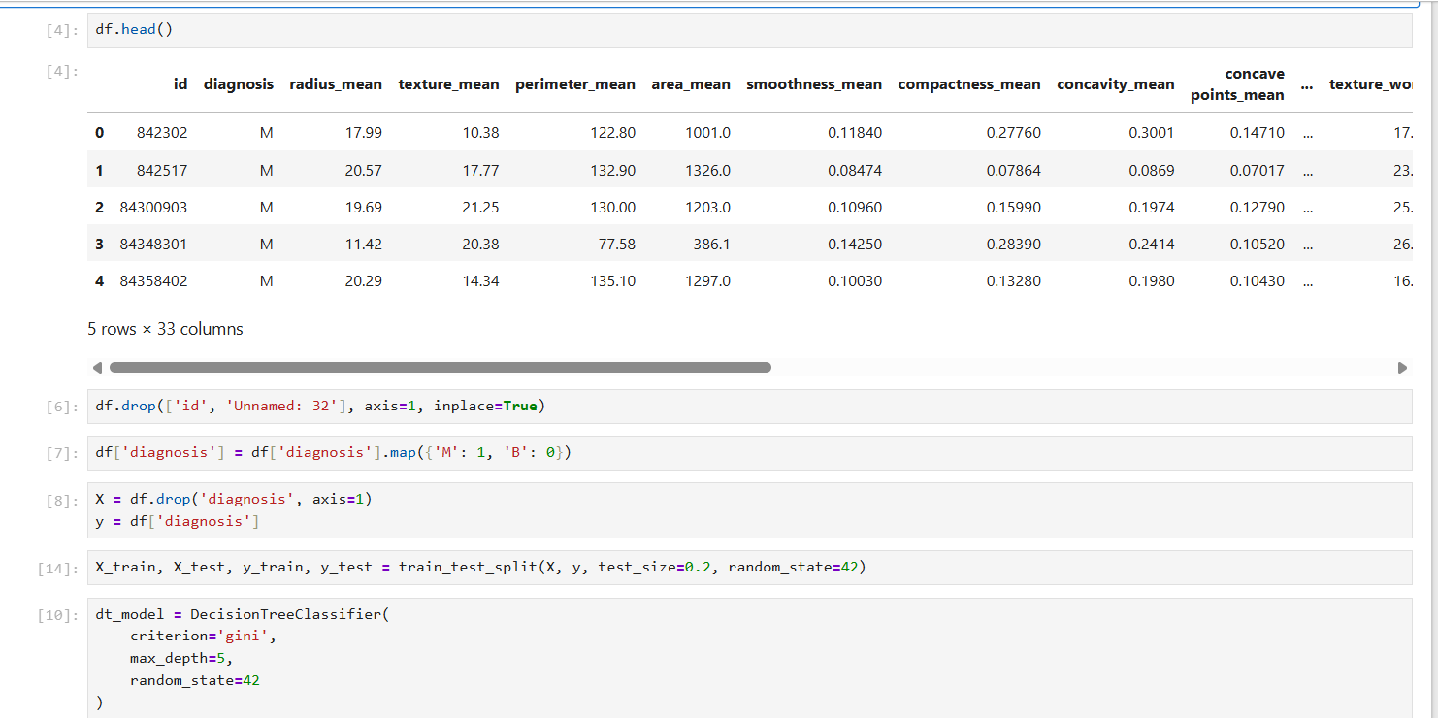
- 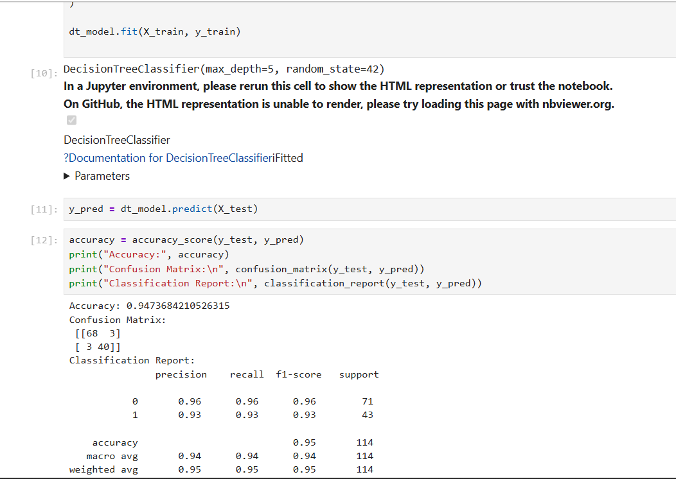
5. Heart Disease Dataset 🫀 (Binary Classification)
- Goal: Predict the presence of heart disease in a patient.
- Why it's good: This is a slightly noisy dataset that is perfect for practicing Pruning. Decision Trees tend to overfit (get too deep and complex); this dataset helps you learn how to limit the max_depth to make the model more general.
- Direct Link: Kaggle - Heart Disease Dataset
- 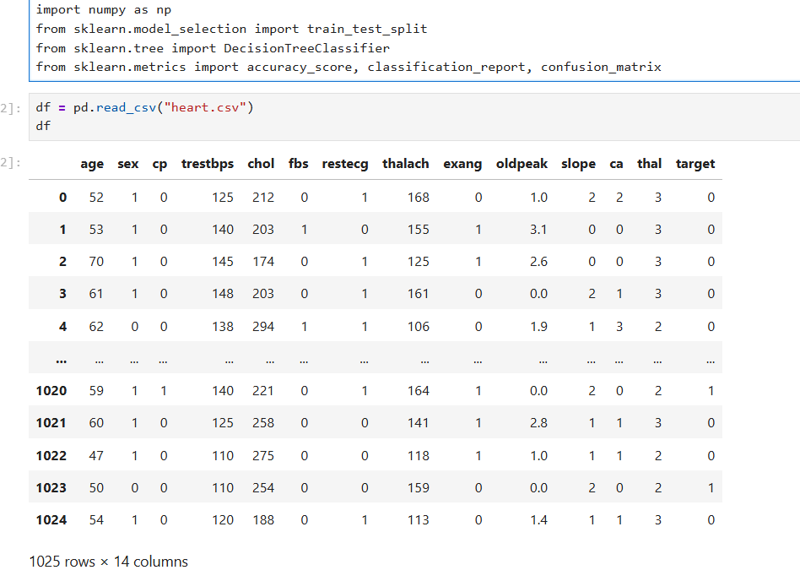
- 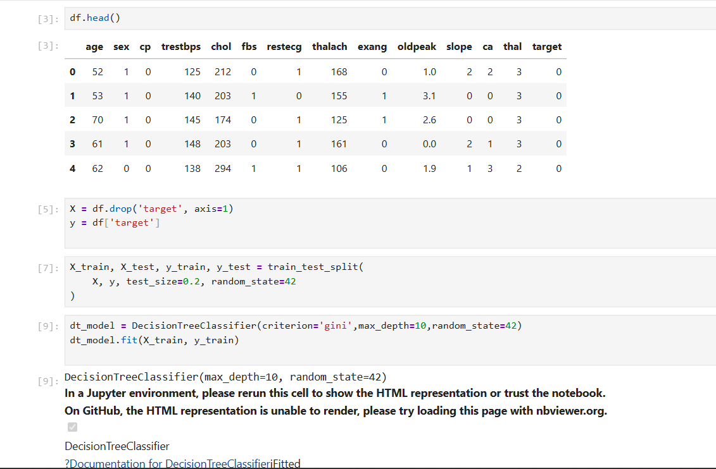
- 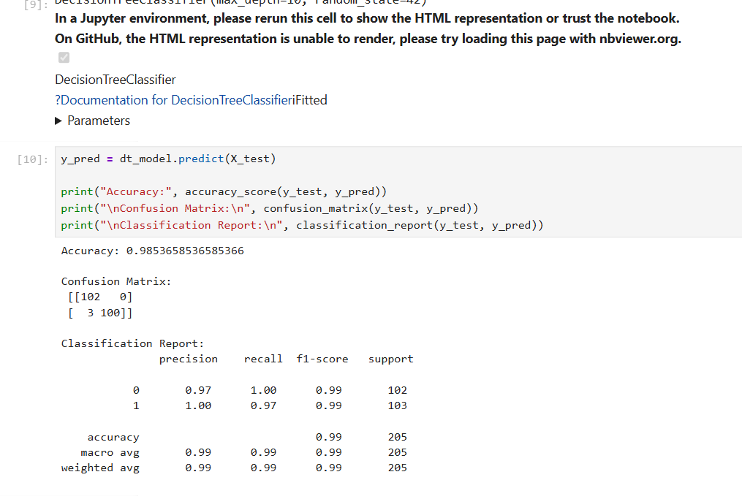

📚 Learning Resources for Decision Trees
To master these datasets, I recommend these direct resources:
- Visual Intuition: StatQuest: Decision Trees — This is the best video for understanding Gini Impurity and how the tree decides where to split.
- Coding Guide: Scikit-Learn Decision Tree Tutorial — The official documentation shows you how to code the model and, importantly, how to export and visualize the tree so you can see it.
- Intermediate Concept (Pruning): Understanding Overfitting in Trees — Read about max_depth and min_samples_leaf to keep your trees from getting too messy.

RESOURCES

1️⃣ StatQuest – Decision Trees (Very Clear & Beginner-Friendly)
⭐ Best for understanding why Decision Trees work
🔗 https://statquest.org/decision-trees/
📺 (Video version — same topic)
🔗 https://www.youtube.com/watch?v=7VeUPuFGJHk
Why it’s great:
✔ Visual explanation
✔ No heavy math
✔ Simple language for beginners

2️⃣ Google Machine Learning Crash Course – Trees Section
⭐ Simple conceptual explanation
🔗 https://developers.google.com/machine-learning/crash-course/decision-trees
Why this helps:
✔ Easy ML crash course format
✔ Helps connect Decision Trees with ML basics
✔ Good for first exposure

3️⃣ Analytics Vidhya – Decision Tree Algorithm
⭐ Great beginner article + examples
🔗 https://www.analyticsvidhya.com/blog/2021/06/decision-tree-algorithm-for-machine-learning/
Why it’s useful:
✔ Step-by-step explanation
✔ Examples + visual diagrams
✔ Covers overfitting & pruning too

4️⃣ GeeksforGeeks – Decision Trees Explanation
⭐ Simple detailed notes
🔗 https://www.geeksforgeeks.org/decision-tree-introduction/
Why it’s helpful:
✔ Easy to read
✔ Good for revision
✔ Bullet-point style learning

5️⃣ Towards Data Science – Decision Trees Tutorial
⭐ Intuitive medium-length read
🔗 https://towardsdatascience.com/decision-trees-in-machine-learning-641b9c4e8052
Why it’s good:
✔ Concepts + diagrams
✔ Covers entropy, Gini index
✔ Great for deeper intuition

6️⃣ W3Schools – Decision Trees in Python
⭐ Simple Python implementation
🔗 https://www.w3schools.com/python/python_ml_decision_tree.asp
Why beginners love it:
✔ Short & clear
✔ Easy example code
✔ Good first Python ML project

7️⃣ Kaggle Learn – Hands-On Classification
⭐ Practice on real datasets
🔗 https://www.kaggle.com/learn/intro-to-machine-learning
Why use it:
✔ Build your own Decision Tree model
✔ Practice with real data
✔ No installation needed
(Search inside for Decision Trees)

8️⃣ scikit-learn Official Docs – Decision Trees
⭐ Industry-standard reference
🔗 https://scikit-learn.org/stable/modules/tree.html
Why it’s useful:
✔ Official API explanation
✔ Examples you can reuse
✔ Learn proper model API usage

Model Evaluation and Performance Metrics used in Machine Learning.

model evaluation & metrics:
✔ Confusion Matrix
✔ Accuracy, Precision, Recall
✔ F1-Score
✔ ROC Curve & AUC
✔ Bias–Variance trade-off
✔ Cross-Validation
Each dataset is well-known, clean, and widely used in ML learning.

✅ 1️⃣ Breast Cancer Wisconsin Dataset (BEST FOR CLASSIFICATION)
🔗 https://www.kaggle.com/datasets/uciml/breast-cancer-wisconsin-data
Why this dataset is perfect
- Binary classification (Malignant / Benign)
- Slight class imbalance
- Ideal for ROC–AUC & F1-score
You can practice
- Confusion Matrix
- Precision vs Recall trade-off
- ROC Curve & AUC
- Cross-validation
- Bias–Variance (simple vs complex models)
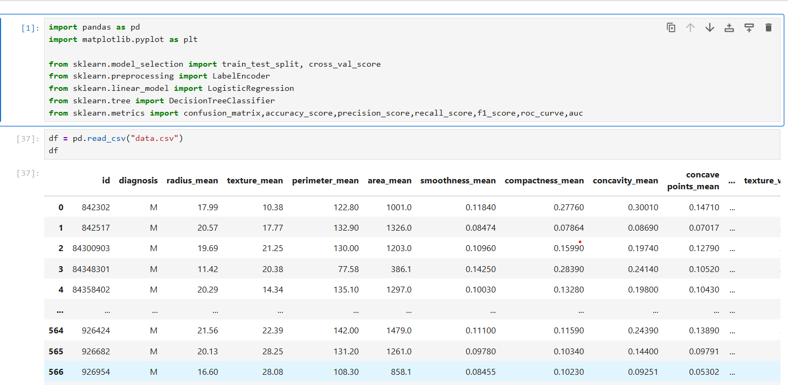
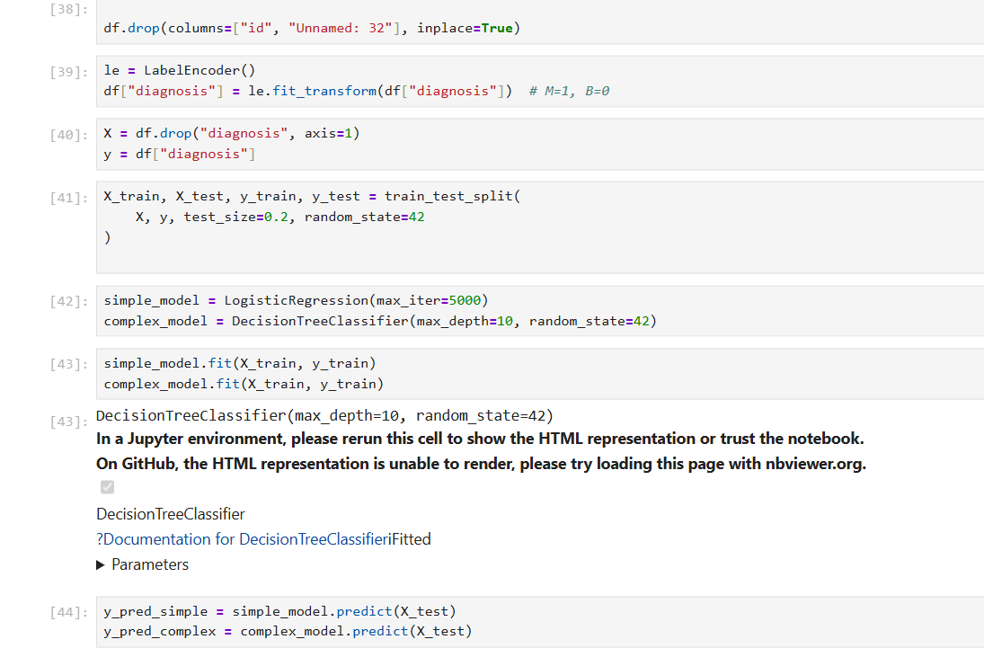
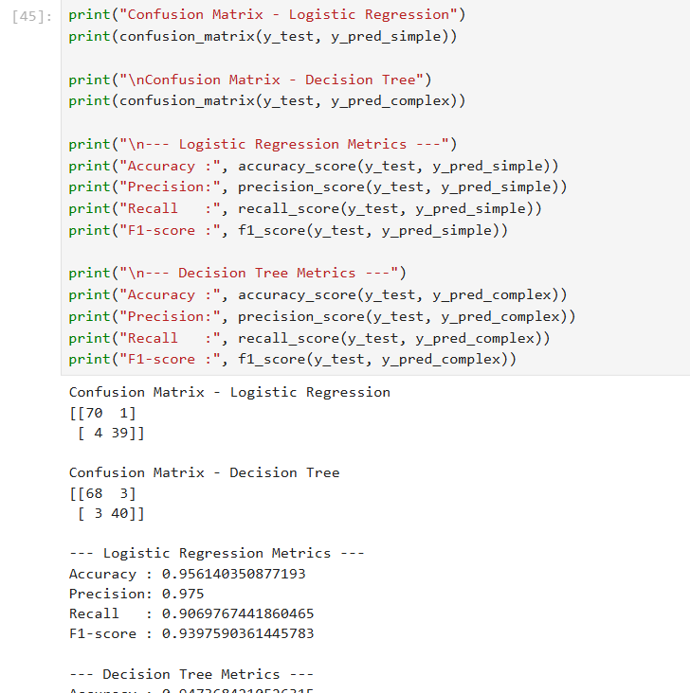
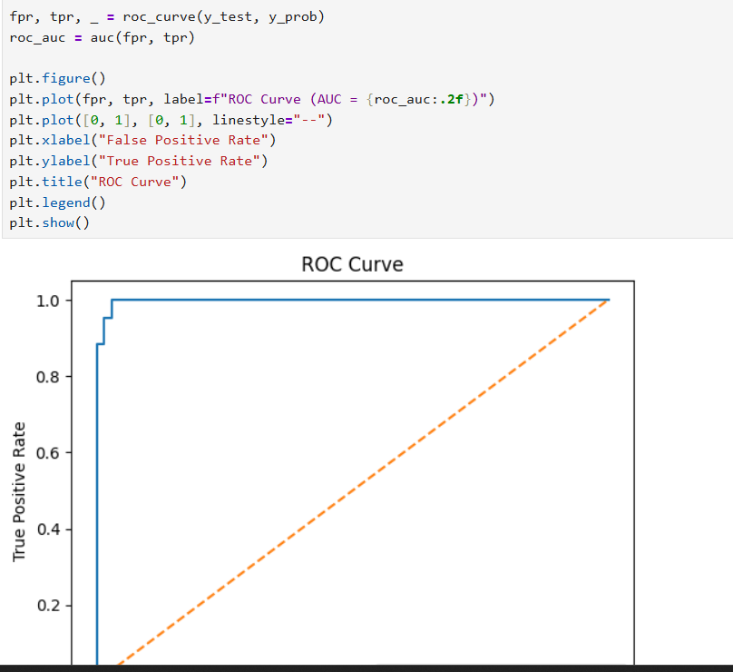
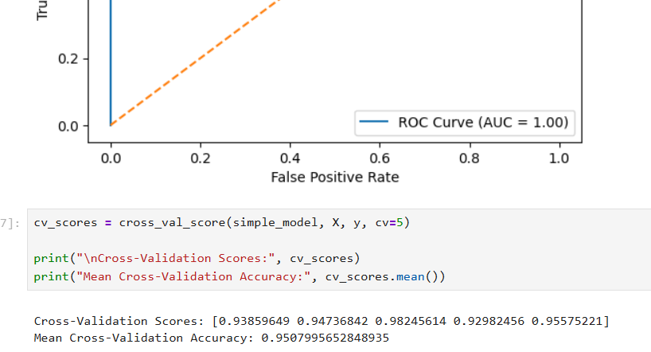
✅ 2️⃣ Titanic Survival Dataset (VERY POPULAR)
🔗 https://www.kaggle.com/competitions/titanic/data
Why it’s great
- Real-world dataset
- Binary output (Survived / Not Survived)
- Some imbalance → accuracy alone is misleading
You can practice
- Why accuracy is not enough
- Precision, Recall, F1
- Confusion Matrix
- Cross-validation
- Feature engineering impact
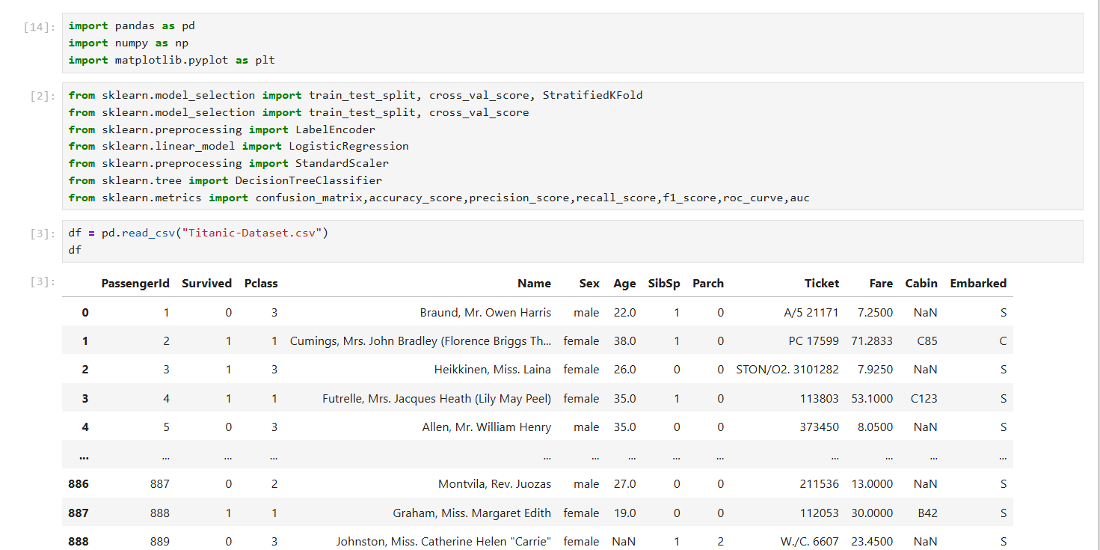
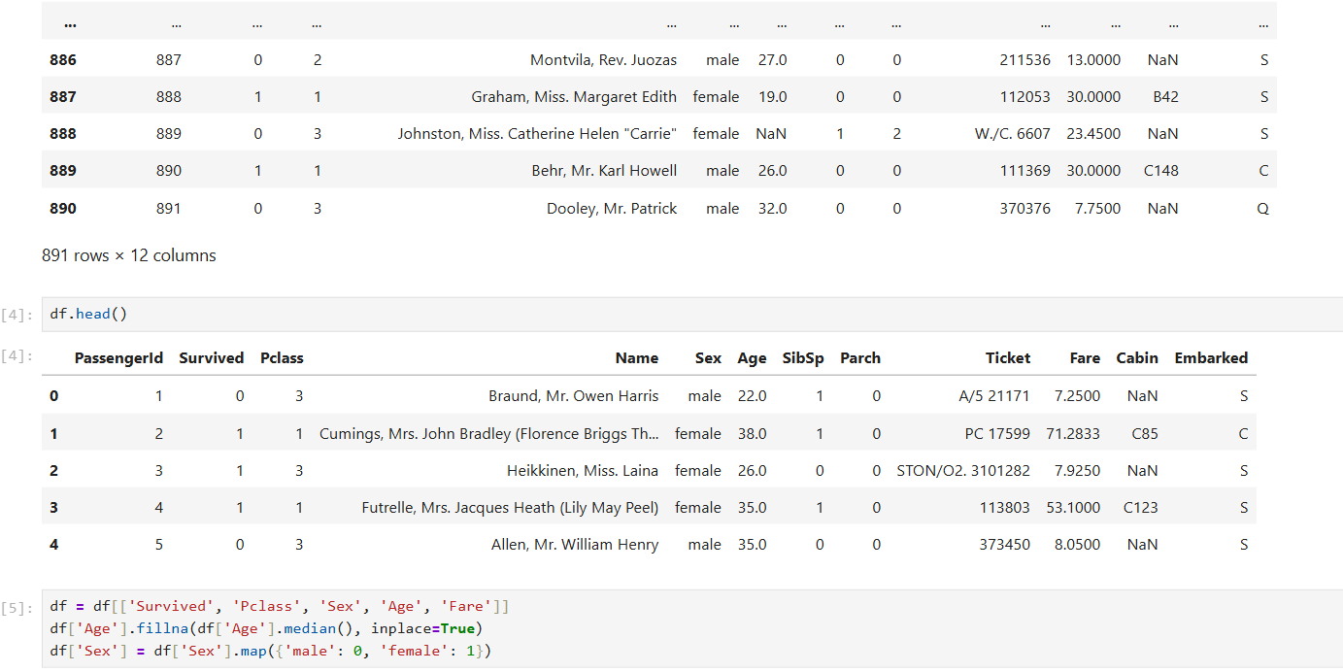
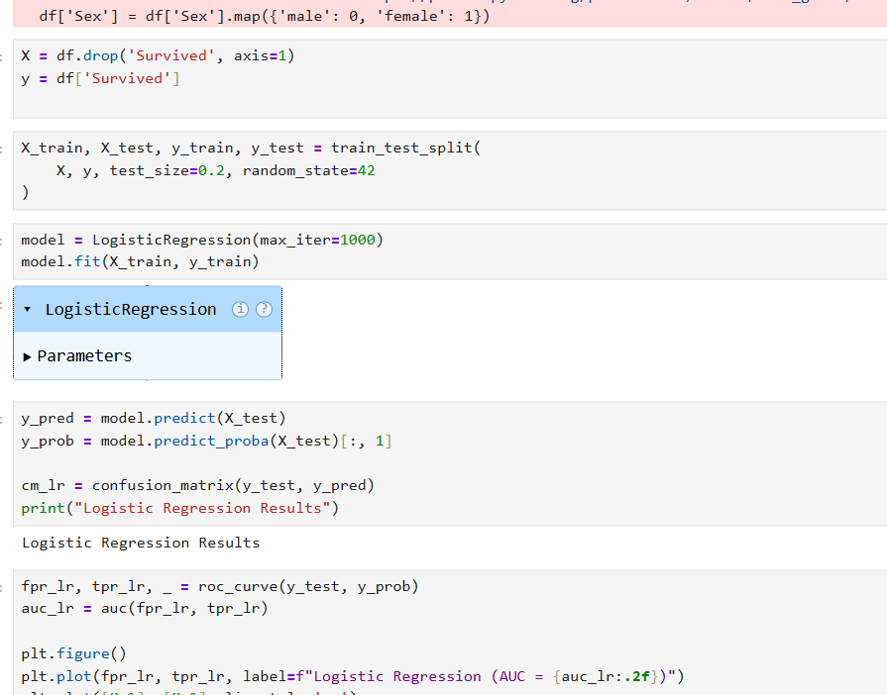
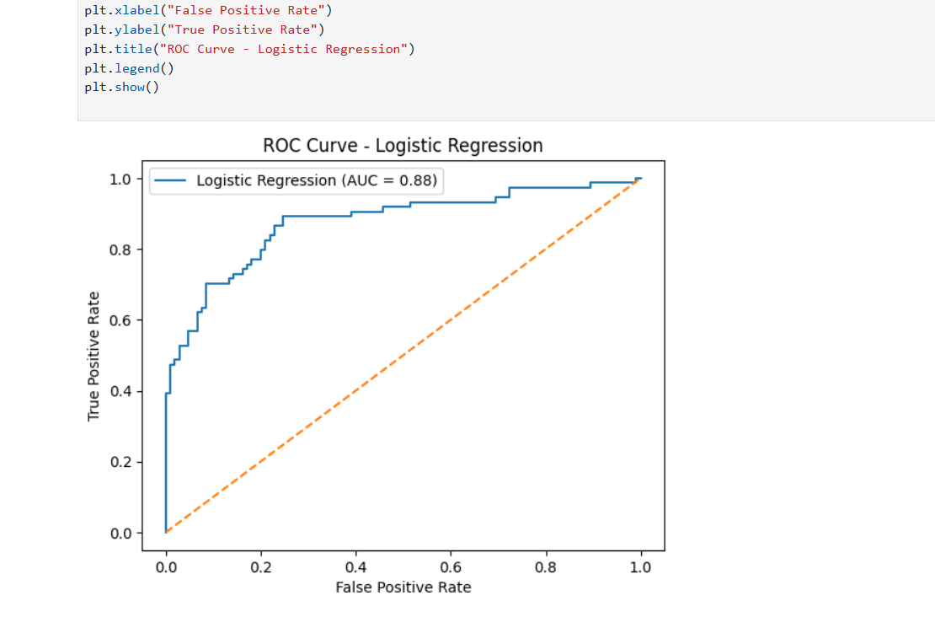
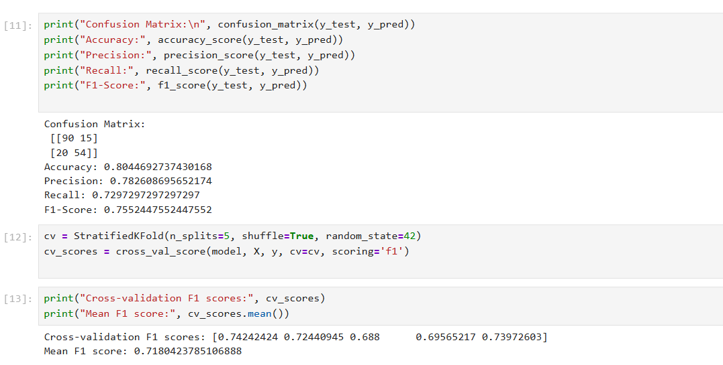
✅ 3️⃣ PIMA Indians Diabetes Dataset
🔗 https://www.kaggle.com/datasets/uciml/pima-indians-diabetes-database
Why this dataset is important
- Medical dataset (0 = No disease, 1 = Disease)
- Recall is more important than accuracy
You can practice
- Recall-focused evaluation
- F1-Score
- ROC Curve & AUC
- Bias–Variance tradeoff
- Cross-validation
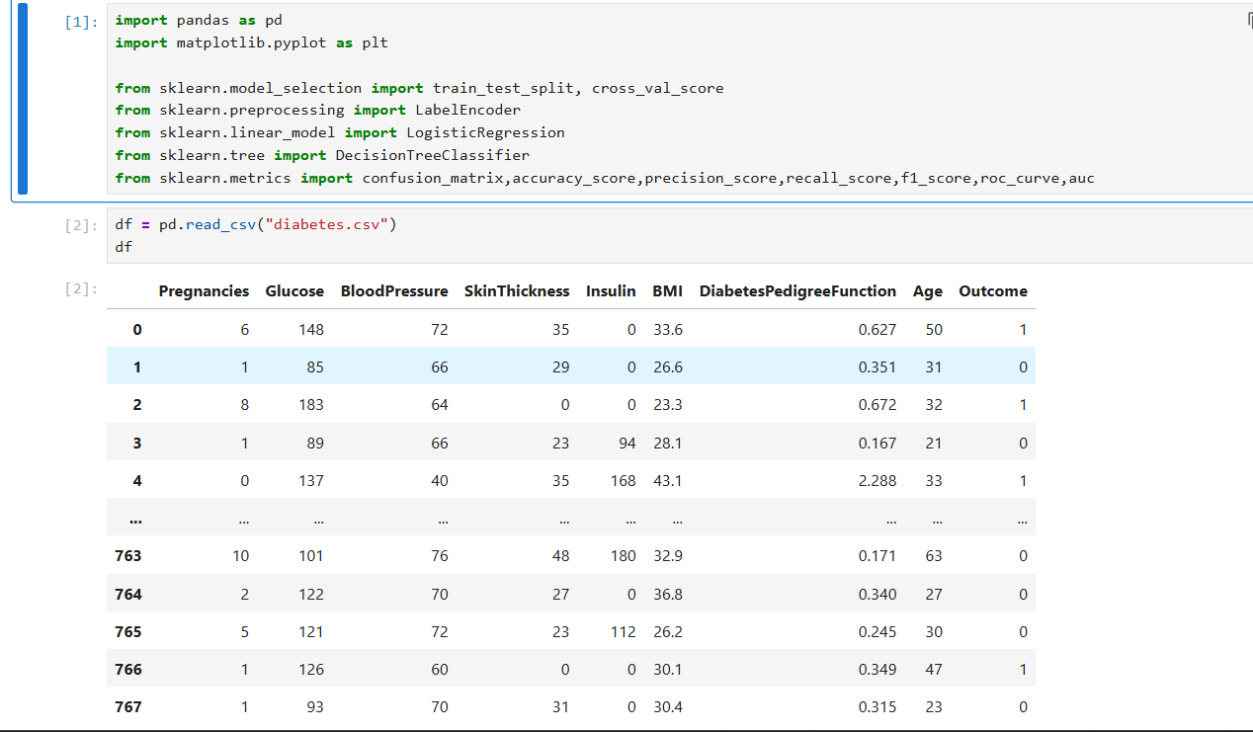
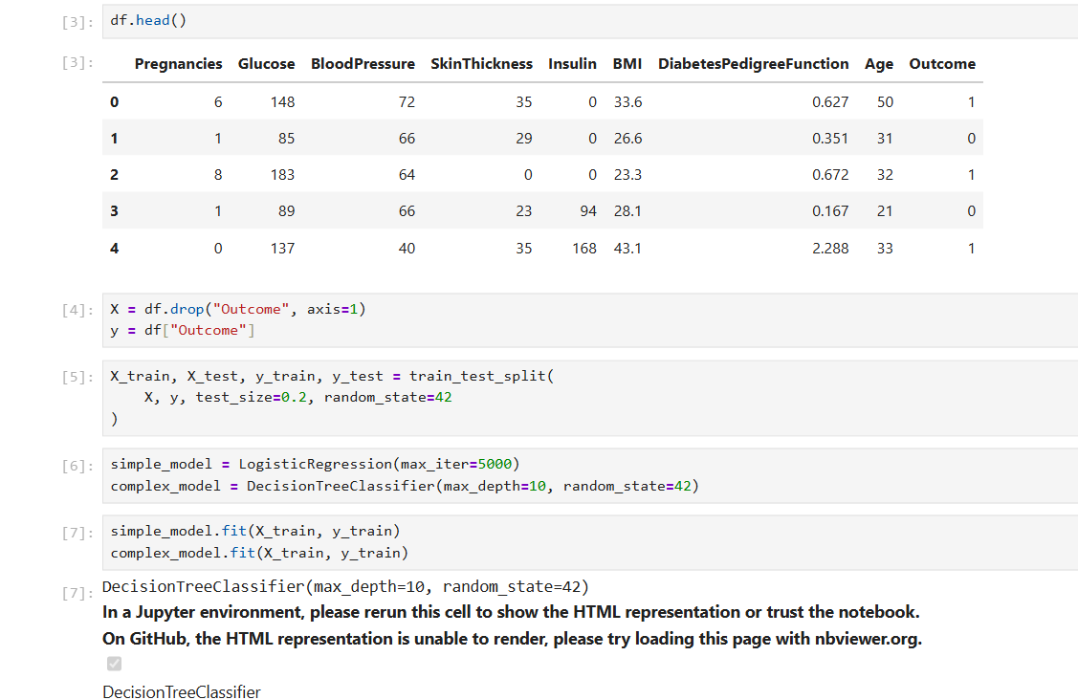
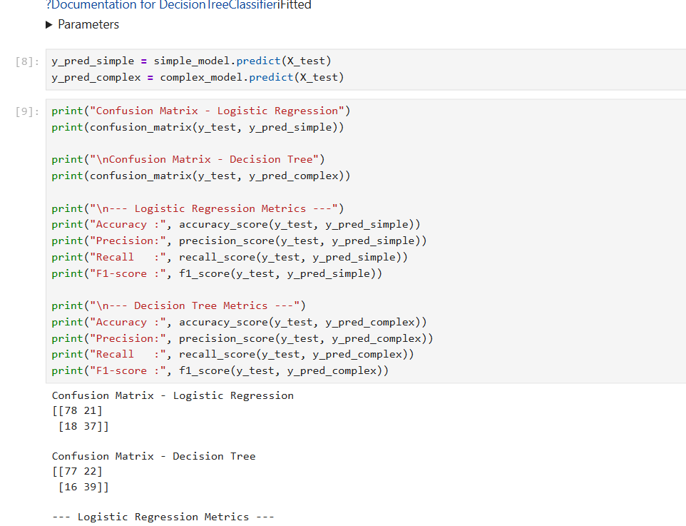
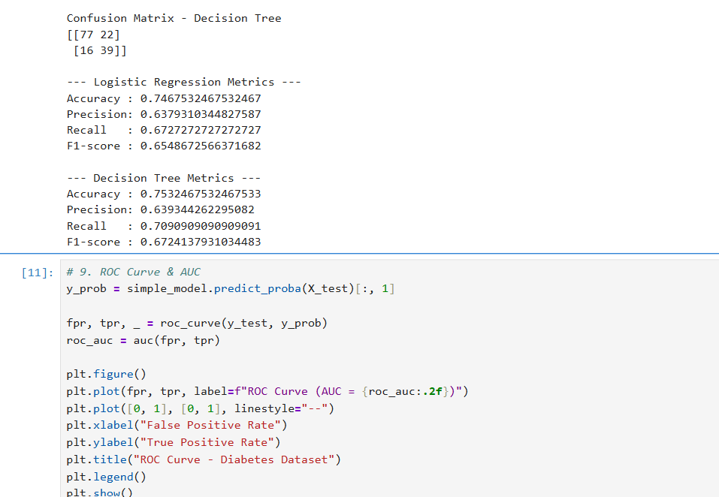
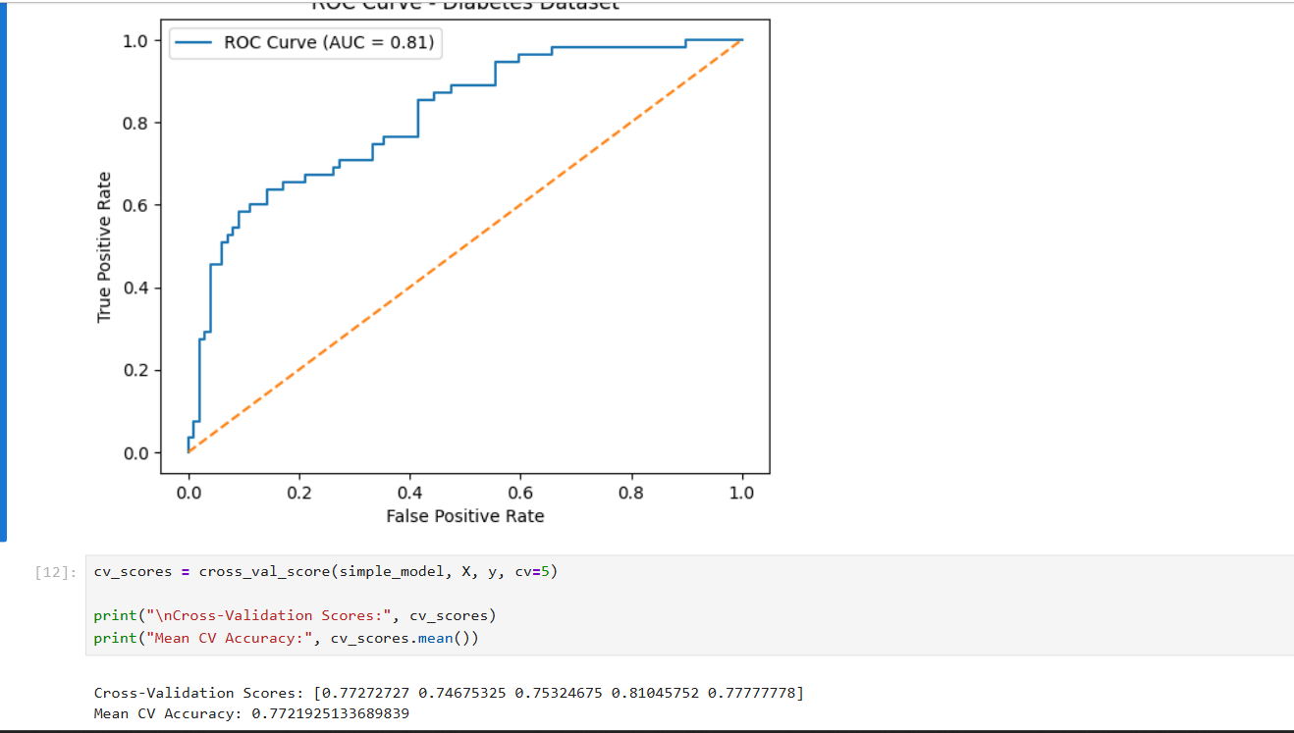
✅ 4️⃣ Credit Card Fraud Detection Dataset (IMBALANCED DATASET ⭐)
🔗 https://www.kaggle.com/datasets/mlg-ulb/creditcardfraud
Why this dataset is excellent
- Highly imbalanced (Fraud is rare)
- Accuracy is completely misleading
You can practice
- Precision vs Recall deeply
- F1-Score
- ROC–AUC
- Why confusion matrix matters
- Cross-validation with imbalance
⚠️ Very important dataset for interviews
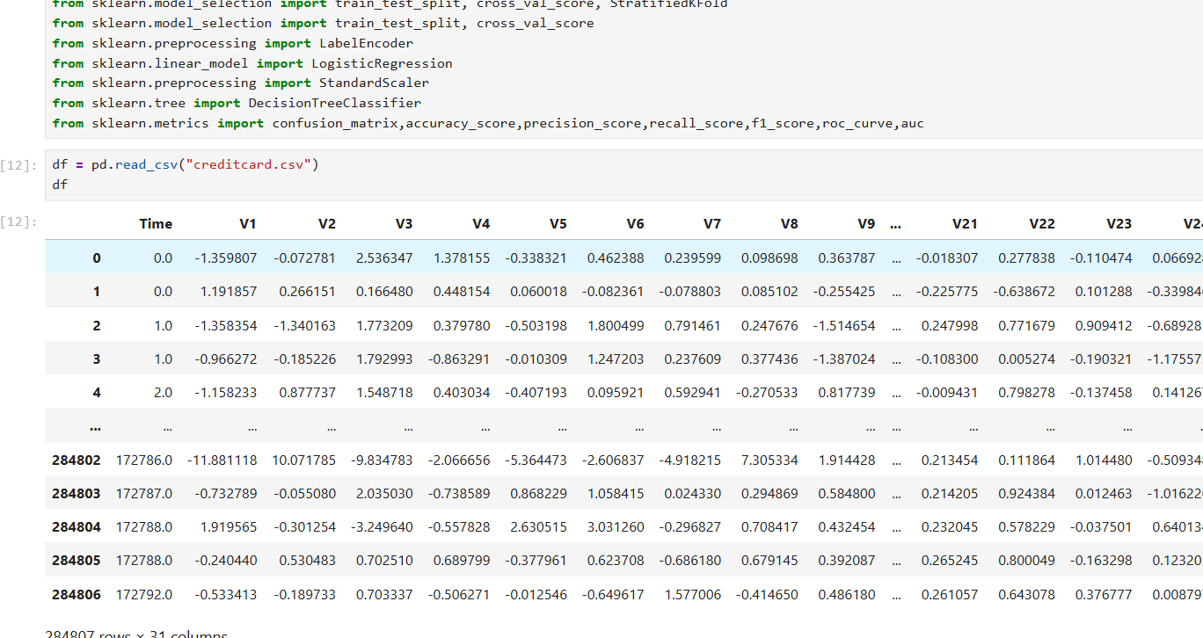
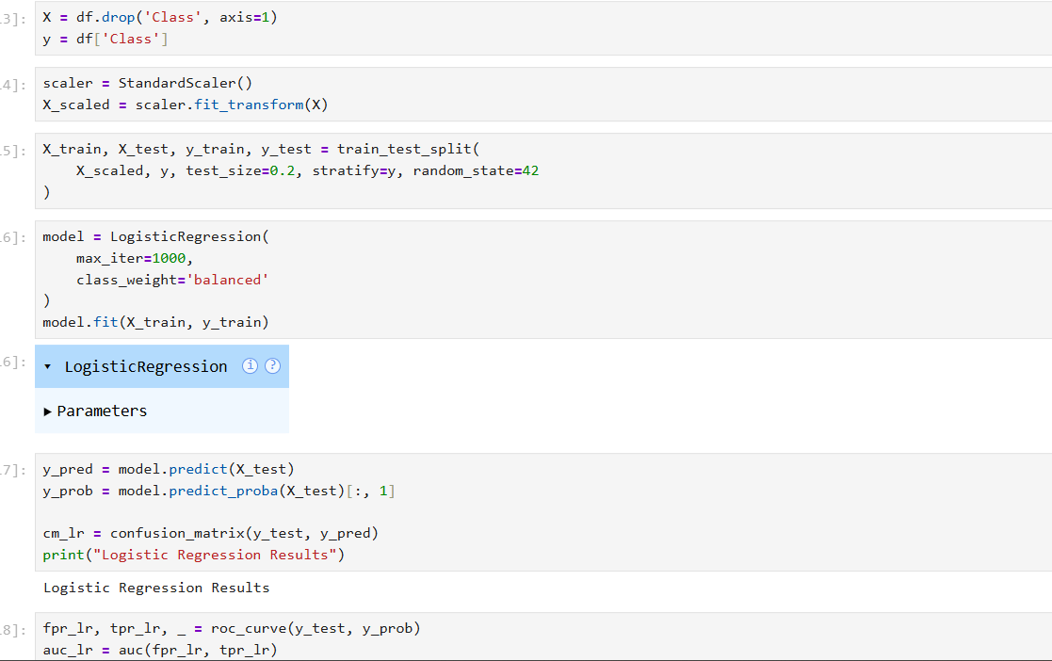\
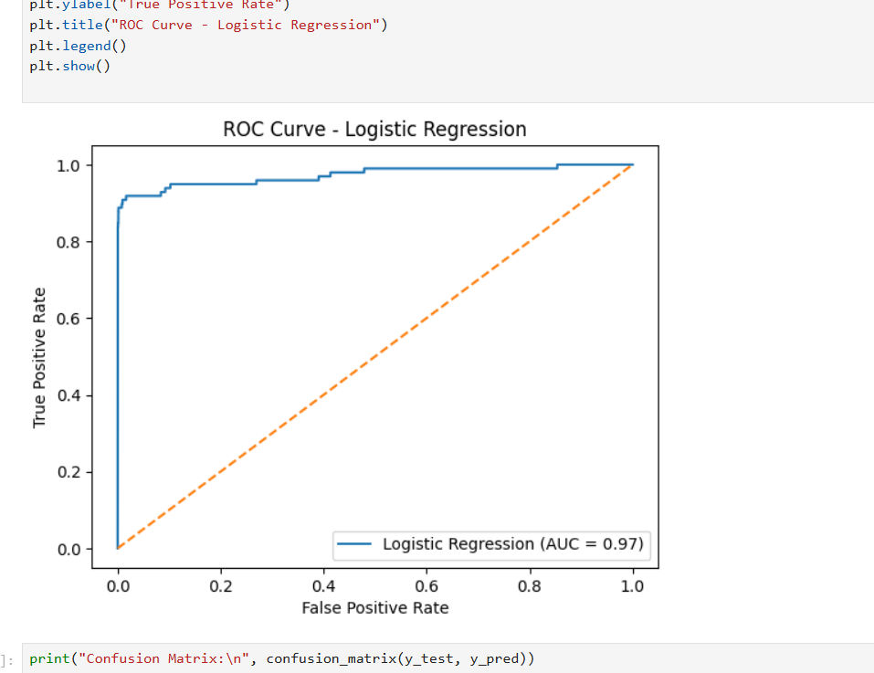
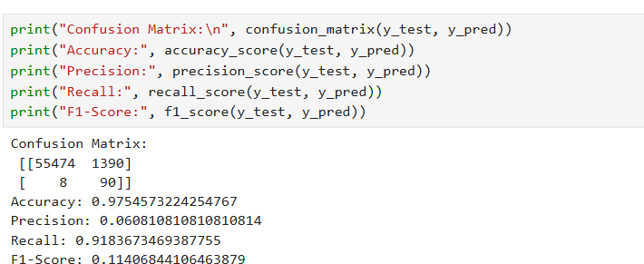

✅ 5️⃣ Student Performance / Pass–Fail Dataset (BEGINNER FRIENDLY)
🔗 https://www.kaggle.com/datasets/devansodariya/student-performance-data
Why it’s good
- Easy to understand
- Binary outcome (Pass / Fail)
- Great for beginners
You can practice
- Confusion Matrix
- Accuracy, Precision, Recall
- Cross-validation
- Bias–Variance (tree depth, K in KNN)
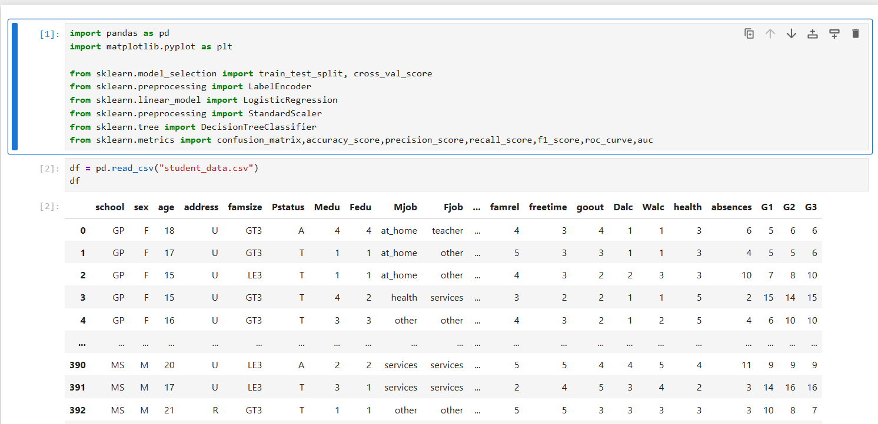
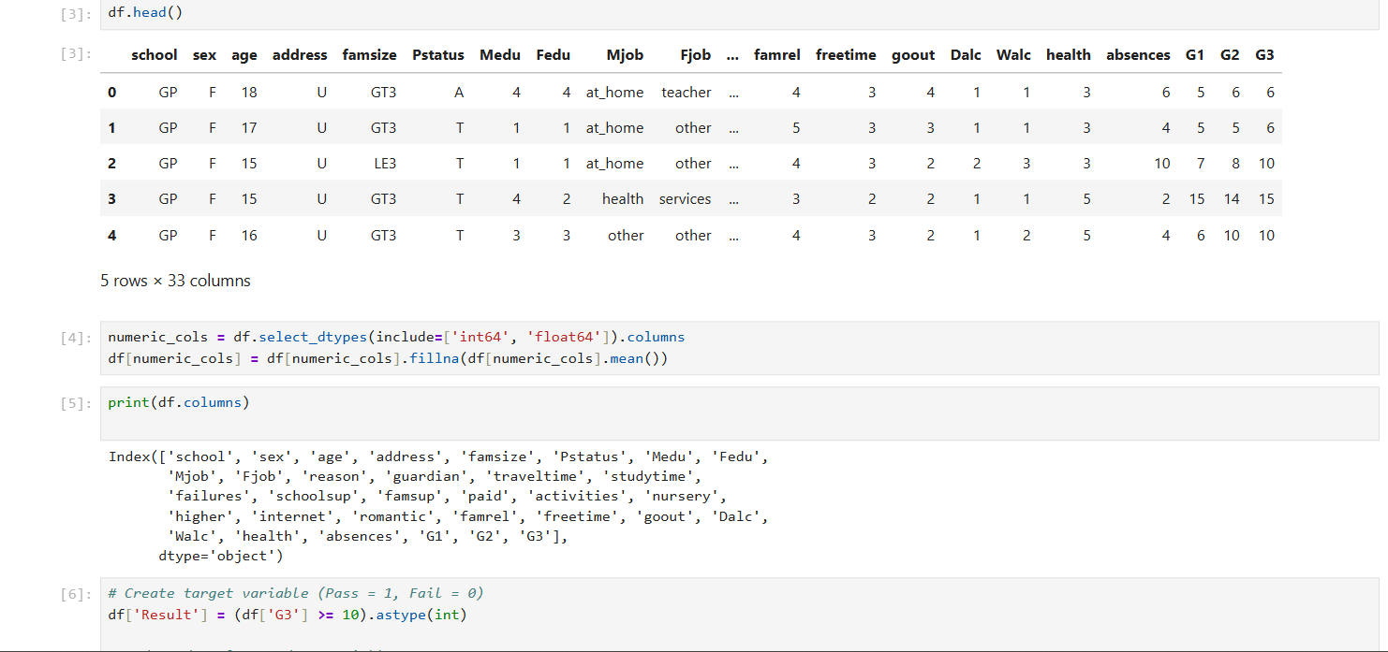
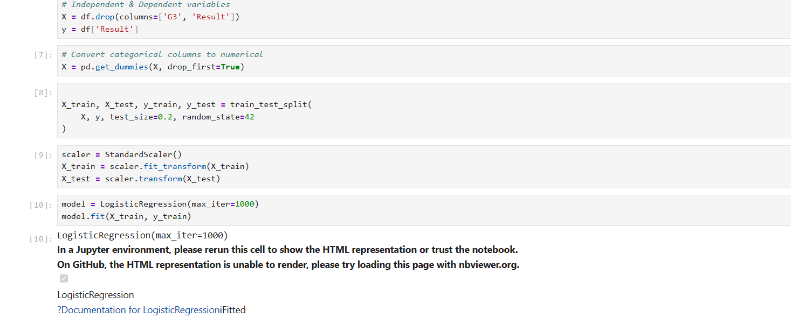
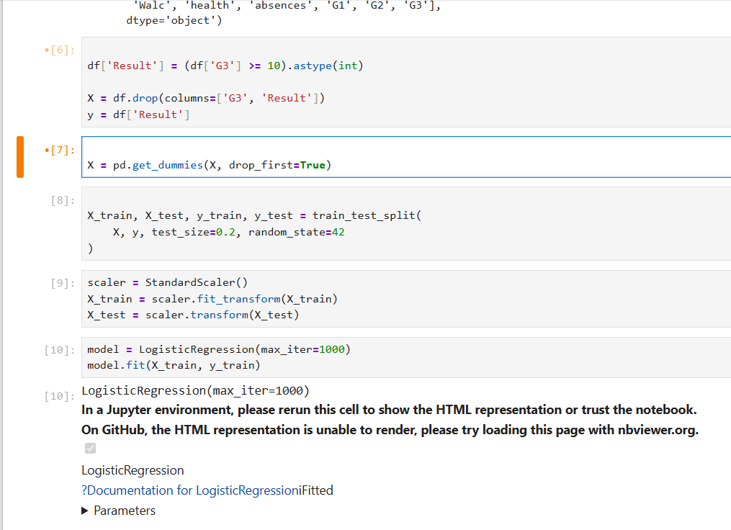
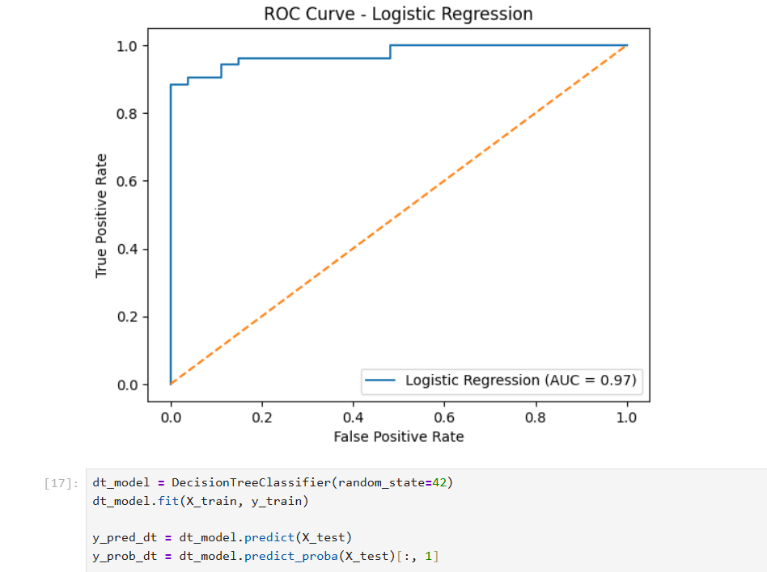
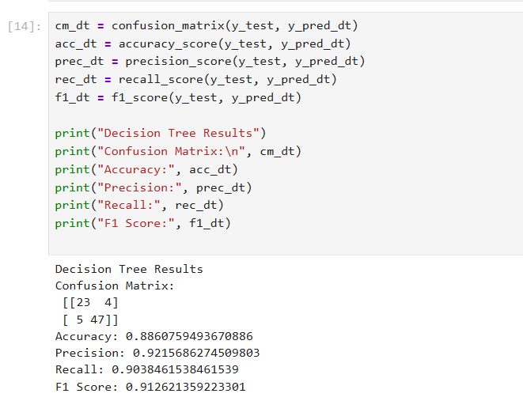
🟢 BEST PRACTICE ORDER (IMPORTANT)
1️⃣ Student Performance
2️⃣ Breast Cancer
3️⃣ Titanic
4️⃣ Diabetes
5️⃣ Credit Card Fraud

🎯 MINI PRACTICE TASK (DO THIS FOR EACH DATASET)
For each dataset, do this checklist ✅:
- Train a model (Logistic / KNN / SVM / Tree)
- Generate Confusion Matrix
- Calculate:
  - Accuracy
  - Precision
  - Recall
  - F1-Score
- Plot ROC Curve & calculate AUC
- Apply Cross-Validation
- Observe Bias vs Variance by changing model complexity

RESOURCES

📊 1️⃣ Confusion Matrix (Deeply)
✔ Towards Data Science – Confusion Matrix Explained
🔗 https://towardsdatascience.com/understanding-confusion-matrix-a9ad42dcfd62
✔ Analytics Vidhya – Confusion Matrix
🔗 https://www.analyticsvidhya.com/blog/2020/10/confusion-matrix-machine-learning/

📊 2️⃣ F1-Score (with examples)
✔ Towards Data Science – F1-Score & Classification Metrics
🔗 https://towardsdatascience.com/precision-recall-and-f1-score-857603091c8a
✔ GeeksforGeeks – F1-Score Explanation
🔗 https://www.geeksforgeeks.org/accuracy-precision-recall-and-f1-score-in-python/

📊 3️⃣ ROC Curve & AUC
✔ Towards Data Science – ROC and AUC
🔗 https://towardsdatascience.com/roc-curves-and-auc-explained-859db5e30eab
✔ Analytics Vidhya – ROC AUC Guide
🔗 https://www.analyticsvidhya.com/blog/2020/06/auc-roc-curve-machine-learning/

📊 4️⃣ Bias–Variance Tradeoff
✔ Machine Learning Mastery – Intuitive Explanation
🔗 https://machinelearningmastery.com/gentle-introduction-to-the-bias-variance-trade-off-in-machine-learning/
✔ Towards Data Science – Bias vs Variance
🔗 https://towardsdatascience.com/understanding-the-bias-variance-tradeoff-165e6942b229

📊 5️⃣ Cross-Validation
✔ scikit-learn Guide – Cross-Validation
🔗 https://scikit-learn.org/stable/modules/cross_validation.html
✔ Towards Data Science – Cross-Validation Explained
🔗 https://towardsdatascience.com/cross-validation-in-machine-learning-72924a69872f

🟢 EXTRA PRACTICE (Interactive / Examples)
✔ Kaggle Learn – Model Evaluation
🔗 https://www.kaggle.com/learn/machine-learning
(Search inside for evaluation metrics, ROC, cross-validation)
✔ W3Schools – ML Metrics
🔗 https://www.w3schools.com/python/python_ml_metrics.asp

LeetCode Problems : Explain and attach screenshot
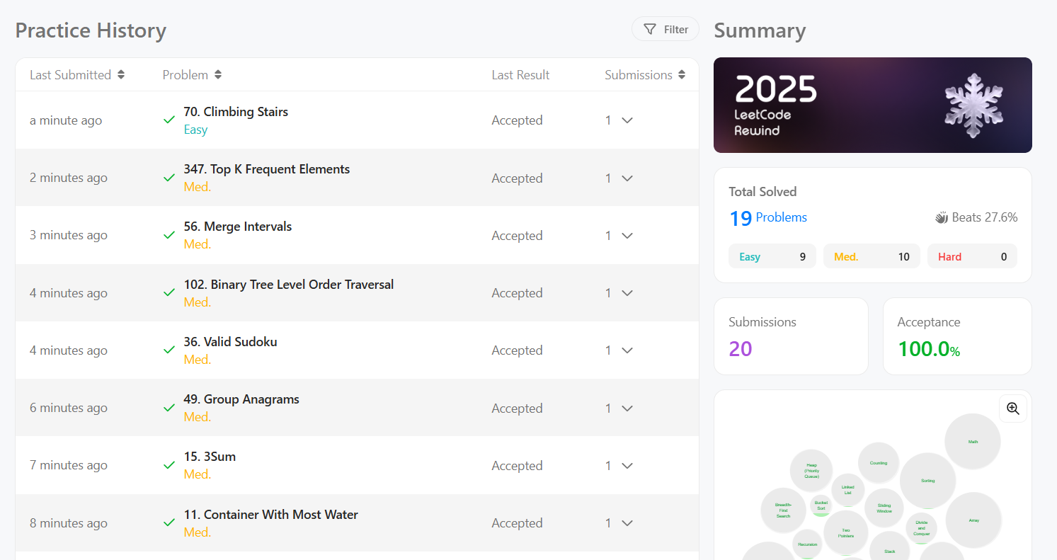

LeetCode Problems : Explain and attach screenshot
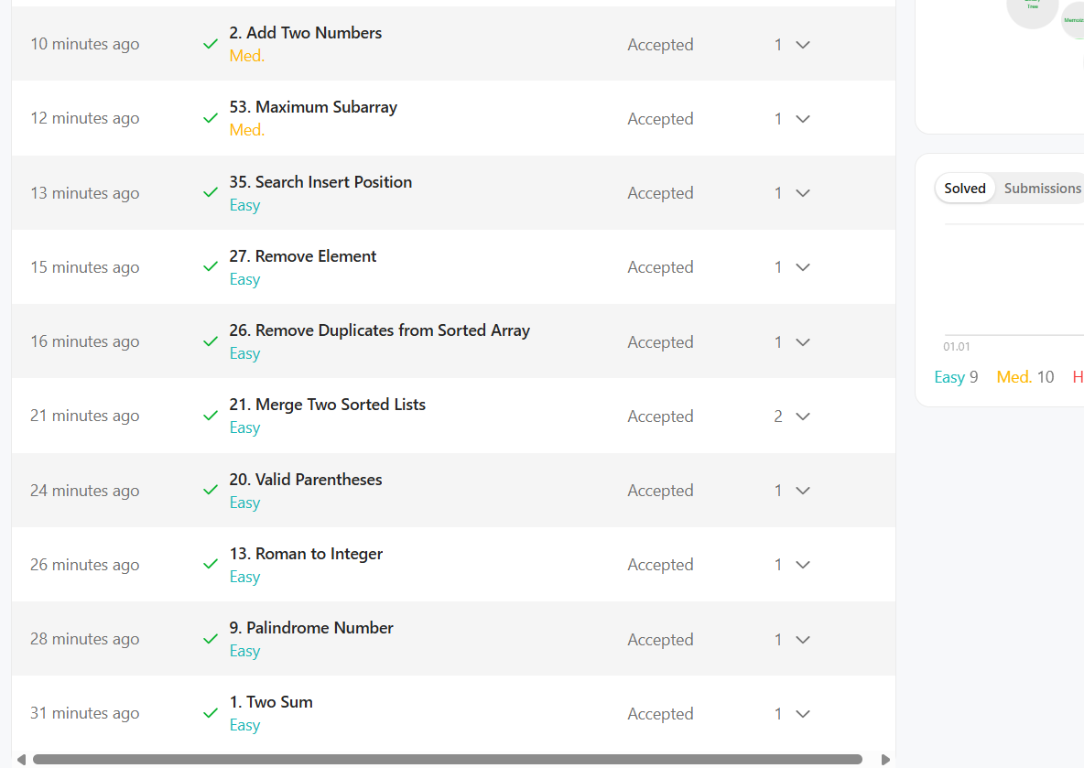

Explain your GitHub submission and attach your submitted Repo screenshot

Explain your LinkedIn Post and attach your submitted Post screenshot

Attach the link of your First Video (YouTube)
https://youtu.be/MUKXDA_ajsM?si=fBtb1lJhDA71sB0p

Attach the link of your Second Video (YouTube)
https://youtu.be/I9svq4yu0kw?si=6L-PXSxxGB20m0JG

MORE RESOURCES

📅 7-DAY PRACTICE PLAN
📊 Model Evaluation & Metrics (Beginner → Confident)

🟢 DAY 1 — Foundations + Confusion Matrix
🎯 Goal
Understand what model evaluation is and master the confusion matrix.
📘 Learn
- What is model evaluation?
- Why accuracy is not enough
- Confusion Matrix (TP, TN, FP, FN)
🌐 Resources
- StatQuest – Confusion Matrix
https://statquest.org/confusion-matrix/
- Analytics Vidhya – Confusion Matrix
https://www.analyticsvidhya.com/blog/2020/10/confusion-matrix-machine-learning/
💻 Practice
- Use Breast Cancer dataset
- Train Logistic Regression
- Print confusion matrix
- Identify TP, FP, FN, TN manually
✅ Output
✔ Confusion matrix printed
✔ Explain each cell in words

🟢 DAY 2 — Accuracy, Precision & Recall
🎯 Goal
Know when to use which metric.
📘 Learn
- Accuracy
- Precision
- Recall
- Precision vs Recall tradeoff
🌐 Resources
- StatQuest – Precision & Recall
https://www.youtube.com/watch?v=0Lq3rFJ8qps
- GeeksforGeeks – Metrics
https://www.geeksforgeeks.org/accuracy-precision-recall-and-f1-score-in-python/
💻 Practice
- Calculate accuracy, precision, recall
- Change threshold (predict_proba > 0.6)
- Observe metric changes
✅ Output
✔ Metric values printed
✔ Short explanation of results

🟢 DAY 3 — F1-Score (Deep Understanding)
🎯 Goal
Understand why F1 exists.
📘 Learn
- Harmonic mean
- Why accuracy fails on imbalanced data
- When F1 is best metric
🌐 Resources
- Towards Data Science – F1 Score
https://towardsdatascience.com/precision-recall-and-f1-score-857603091c8a
- StatQuest – F1 Score
https://www.youtube.com/watch?v=Kdsp6soqA7o
💻 Practice
- Compute F1-Score
- Compare with accuracy
- Use Diabetes dataset
✅ Output
✔ F1-Score calculated
✔ Clear comparison with accuracy

🟢 DAY 4 — ROC Curve & AUC
🎯 Goal
Learn probability-based evaluation.
📘 Learn
- ROC Curve
- True Positive Rate
- False Positive Rate
- AUC interpretation
🌐 Resources
- StatQuest – ROC & AUC
https://www.youtube.com/watch?v=4jRBRDbJemM
- Analytics Vidhya – ROC AUC
https://www.analyticsvidhya.com/blog/2020/06/auc-roc-curve-machine-learning/
💻 Practice
- Plot ROC curve
- Compute AUC
- Compare 2 models (Logistic vs KNN)
✅ Output
✔ ROC plot
✔ AUC value

🟢 DAY 5 — Bias–Variance Tradeoff
🎯 Goal
Understand overfitting vs underfitting.
📘 Learn
- Bias
- Variance
- Model complexity
🌐 Resources
- StatQuest – Bias vs Variance
https://www.youtube.com/watch?v=EuBBz3bI-aA
- Machine Learning Mastery
https://machinelearningmastery.com/gentle-introduction-to-the-bias-variance-trade-off-in-machine-learning/
💻 Practice
- Train Decision Tree with:
  - small depth
  - large depth
- Compare train vs test accuracy
✅ Output
✔ Identify overfitting & underfitting

🟢 DAY 6 — Cross-Validation
🎯 Goal
Learn proper model validation.
📘 Learn
- Why train-test split is not enough
- K-Fold Cross-Validation
🌐 Resources
- StatQuest – Cross Validation
https://www.youtube.com/watch?v=fSytzGwwBVw
- scikit-learn Docs
https://scikit-learn.org/stable/modules/cross_validation.html
💻 Practice
- Apply 5-fold cross-validation
- Compare CV score vs test score
✅ Output
✔ CV scores printed
✔ Mean accuracy calculated

🟢 DAY 7 — Mini Project (ALL METRICS)
🎯 Goal
Apply everything together.
📘 Dataset
- Titanic OR Student Performance OR Breast Cancer
💻 Tasks
- Load dataset
- Train model
- Generate confusion matrix
- Calculate accuracy, precision, recall, F1
- Plot ROC & compute AUC
- Apply cross-validation
- Explain bias–variance behavior

